Specific Design Details v2.0

Ocean’s 7

Hassan Alahmed, Abby Caballero, Kyle Harlow,

Daniel Henderson, Yuvin Kokuhennadige, Cassandra Noice

February 9th, 2017

# Power Boards

One of the three main subsystems in Ocean’s 7’s products are the power boards for the Robosub vehicle. There are two power board with one PCB for the current merge circuit and the other PCB for power converters to take in 14.8V from the merge circuit board and convert it into various voltage levels to power each of the other systems on the UAV. Additionally, the merge circuit board and power converters board will contain a microcontroller on each board for current sensing. As such, this subsystem will be two PCBs containing the following:

* Current merge circuit:
  + 2 Wire-to-Board connectors to connect two 14.8V, 100A Lithium Polymer batteries. 8 AWG, Mini-Fit Sr.™ Power Wire-to-Board Connectors (Molex).
  + 2 LTC4357 Positive High Voltage Diode Controllers
  + Teensy development board for current sensing.
  + 5V switching regulator to power the Teensy
  + AD8217 Zero-Drift Current Shunt Monitors to find current through sense resistors.
  + Infineon OptiMOSTM Power-MOSFETs for the Kill Switch to shut off motors when needed.

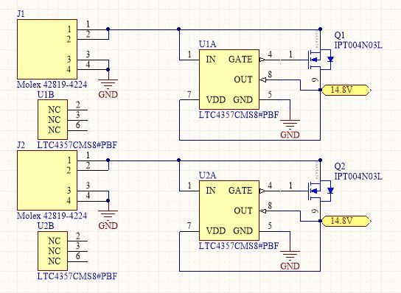

Figure 1.1. Schematic for the merge circuit developed so far. Current sensing devices and the kill switch will be added to this schematic.

* Power converters board
  + 5V, 1A buck conversion circuit using Recom R-78E5.0-1.0 Switching Regulator
  + 12V, 3A conversion circuit using LTC3780 High Efficiency, Switching Buck Converter
  + 19V, 4A conversion circuit using LTC3780 High Efficiency, Switching Boost Converter
  + 2 48V, (1A and 0.5A) conversion circuits using LT3958 Boost Converter
  + Teensy development board for current sensing.
  + AD8217 Zero-Drift Current Shunt Monitors to find current through sense resistors

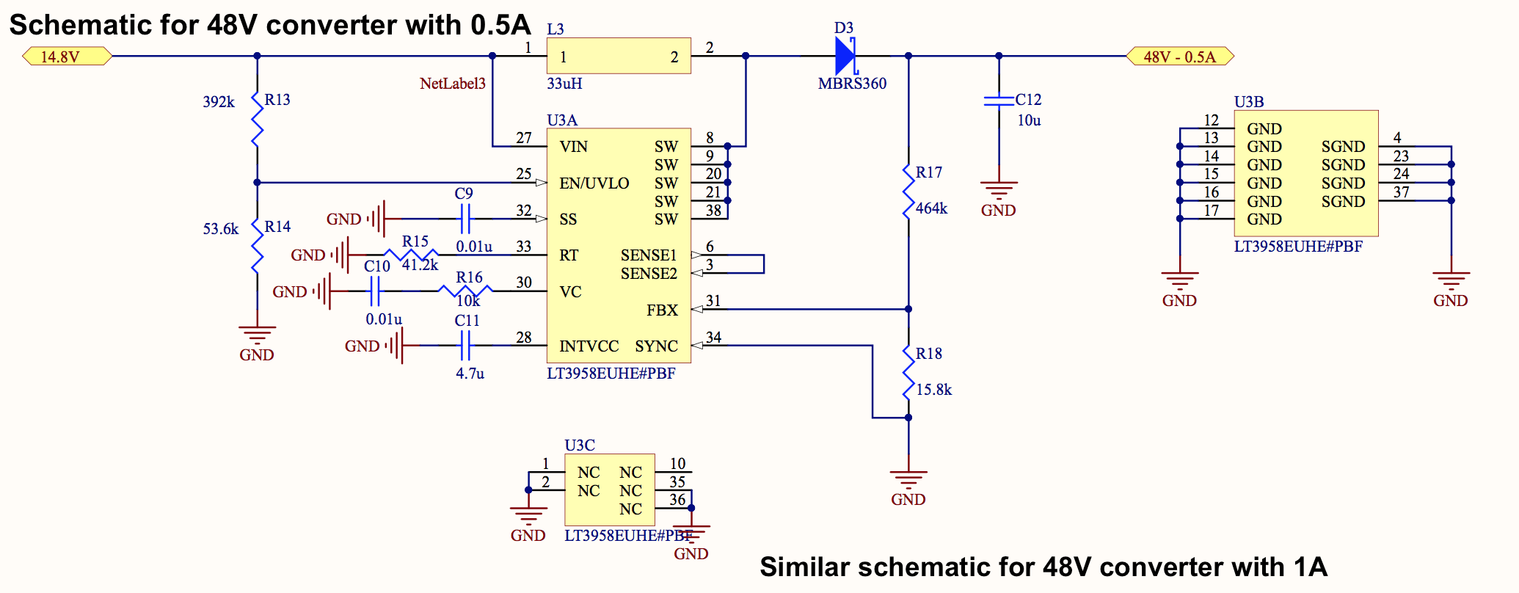

Figure 1.2. Schematic for 14.8V to 48V converter at 0.5 Amps (the 48V converter at 1Amps will be implemented by putting two of these circuits in parallel.)

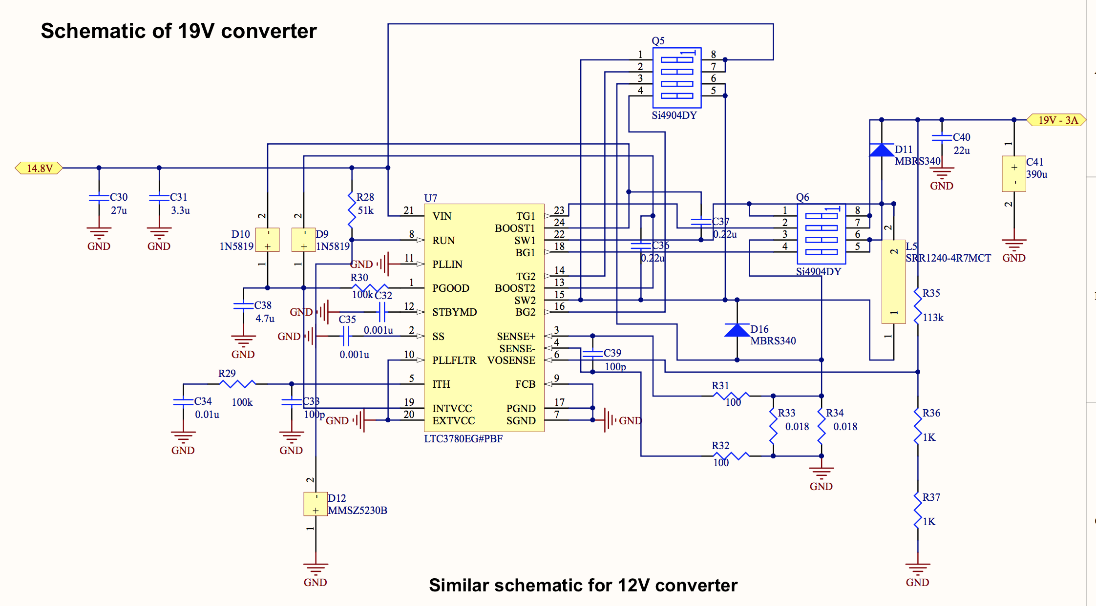

Figure 1.3. Schematic for 14.8V to 19V converter at 4 Amps (the 14.8V to 12V buck converter schematic will be same but with different passive components.)

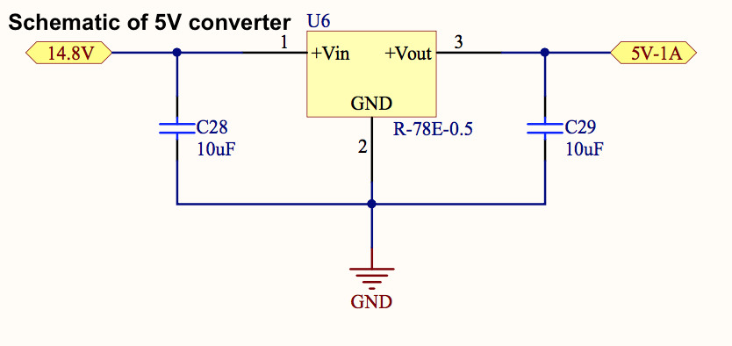

Figure 1.4. Schematic for 14.8V to 5V Switching Regulator.

## 1.1 Proof of Concept Test Results

* **Current Merge Circuit:** The circuit worked successfully. We were able to sense which battery has the higher voltage and only draw current from that battery till the voltage of that battery became equal to the other battery voltage. This makes sure that both batteries discharge at the same rate.
* **14.8V to 5V converter:** The buck conversion circuit worked successfully as expected because of the simplicity of the switching regulator circuit.
* **14.8V to 12V converter:** Thebuck conversion circuit failed due to a manufacturing defect. One of the LTC3780 pin traces was running very close to a ground plane via, and they shorted together. We are redesigning the 12V converter that is similar to the 19V converter but with different passive converters.
* **14.8V to 19V converter:** The boost conversion circuit partially worked. We were able to get 19V, but only when we drew 1 Amp. When we were drawing 4 Amps (the required current) the voltage dropped from 19V to 3V. To fix this we are changing some components like inductors to let this circuit draw 4A.
* **14.8V to 48V converter:** The boost conversion circuit worked successfully. However, we had three identical versions of the 48V conversion circuit, and only one of them worked successfully. The reason behind the failure of the other two were soldering issues. The LT3958 has quad-flat no-leads (QFN) which makes it hard to solder without shorting some of the pins. We are going to be more cautious in soldering these parts to avoid shorts in the future.

## 1.2 Risk Assessments And Mitigation Plans

Below is a list of risks and our contingency plans for the power board:

|  |  |
| --- | --- |
| Risks | Contingency Plan |
| PCB delamination due to high temperatures within the UAV | Epoxy the entire board |
| Hole flooding due to a leak in the hull | Use mineral oil to fill the hull |

## 1.3 Bill of Materials

Bill of Materials for the Power subsystem (Detailed bill of materials included in Appendix 1):

|  |  |  |  |
| --- | --- | --- | --- |
| Item | Price ($) | Quantity | Subtotal ($) |
| 2-layer PCB | 43 | 2 (x3 revisions) | 258 |
| Resistors | 0.013 - 1.27 | 139 | 12.29 |
| Capacitors | 0.073 - 1.76 | 136 | 33.32 |
| Diods | 0.15 - 0.48 | 35 | 12.58 |
| MOSFETs | 0.89 - 3.39 | 17 | 31.26 |
| ICs | 3.39 - 9.55 | 14 | 83.29 |
| Inductors | 0.97 - 5.68 | 9 | 22.86 |
| Teensy 3.2 | 20 | 2 (One already available) | 20 |
| Misc. Parts | - | - | 30 |
| LiPo batteries | 6 | 12 | - |
| Shipping | - | - | 50 |
|  |  | **Total ($)** | 553.6 |

# Backplane

The second subsystem in Ocean’s 7’s project is the backplane. This is a board used to route all power traces and PWM signal traces throughout the hull of the Robosub UAV. The backplane will contain connections to the merge circuit, ESC, power converters, controls and batteries. To this end, this subsystem will be:

* + Power traces: 5V, 12V, 14.8V, 19V and two traces of 48V
  + Wire-to-board Nano-Fit Power Connectors to connect power traces to CPU, DVL, electromagnetic actuators and camera.
  + PWM signal traces from controls board to the ESCs.
  + Digital Components: Molex Nano-Fit Power Connectors
  + 8x Motors: 3-pin header
  + Board-to-Board Molex ExtremePower Edge Connectors for merge circuit board, power conversion board, ESCs and controls board.

## 2.1 Proof of Concept Results

* **Communication Failures due to EMF:** At PoC, we experienced a loss of data along the backplane due to electromagnetic interference from a power drill. Further testing showed that this is very rare, but potentially harmful. Our mitigation plan is to move all peripheral drivers (DVL, IMU, etc.) to the CPU via shielded cables, and plug a shielded USB cable directly from the CPU to the microcontroller board, thereby eliminating communication traces from the backplane.

## 2.2 Risk Assessments And Mitigation Plans

Below is a list of risks and our contingency plans for the backplane:

|  |  |
| --- | --- |
| Risks | Contingency Plan |
| Excessive heating from the 200A trace | Minimize trace length from the current merge circuit to the ESCs |
| PCB delamination due to high temperatures within the UAV | Epoxy the entire board |
| Trace failure (due to heating, soldering, etc.) | Liquid electrical tape |
| Hole flooding due to a leak in the hull | Use mineral oil to fill the hull |

## 2.3 Bill of Materials

Bill of Materials for the Backplane subsystem (Detailed bill of materials included in Appendix 1):

|  |  |  |  |
| --- | --- | --- | --- |
| Item | Price ($) | Quantity | Subtotal ($) |
| 2-layer PCB | 43 | 1 (x3 revisions) | 129 |
| Power MOSFETs | 6 | 12 | 76 |
| MOLEXs | - | 30 | - |
| Misc. Parts | - | - | 80 |
| Shipping | - | - | 50 |
|  |  | **Total ($)** | 335 |

# Controls System

The controls system is one of the most crucial subsystems in the Robosub UAV. This will be a single PCB with a microcontroller, voltage regulator, UART/USB communication traces, slot connector for attaching to the backplane, and a PWM signal output to each of the 8 Electronic Speed Controllers (ESC) on the sub. Additionally, this board will require a JTAG programming interface to load code onto it. As such, the board will contain:

* STM32F767 ARM Cortex M7 microcontroller
  + PID controls algorithms, first modeled and tuned in Matlab and Simulink
  + UART transmission interface and received data parser
  + Drivers for PWM control
  + Primarily interrupt-based
* Connector Pads for Molex ExtremePower Edge Connector
* UART-to-USB via FT232 IC
* JTAG header (for use with the ST-Link/V2 programmer)
* LEDs for PWM status, power status, communication status (debugging purposes)
* TI LM3940 Linear Regulator (5V to 3.3V)

## 3.1 Proof of Concept Results

* **Code:** For PoC, we implemented UART and PWM drivers on the STM32 F7 we’ll be putting on our board, and showed that we can use UART to control our motors very practically. This code will simply be ported to the controls board once fabricated.

## 3.2 Risk Assessments And Mitigation Plans

Below is our list of risks and their respective contingency plans for the controls team:

|  |  |
| --- | --- |
| Risks | Contingency Plan |
| Possibility of mechanical team changing motor placement | Communication is key, but we would need to redesign controllers |
| Need actual robot in order to tune effectively, there is a possibility that we may not have the robot ready until much later | May need to design controller for old submarine system if new system will not be ready in time |
| PCB delamination due to high temperatures within the UAV | Epoxy the entire board |
| Unable to purchase certain necessary sensors, we must not break the ones we already have | Send parts back to manufacturer for repair |
| Need to coordinate with other teams for integration, this usually causes unforeseen issues | Lots of communication and plan as much time as possible for integration |

## 3.3 Bill of Materials

Bill of Materials for the controls system (Detailed bill of materials included in Appendix 1):

|  |  |  |  |
| --- | --- | --- | --- |
| Item | Price ($) | Quantity | Subtotal ($) |
| Microcontroller | 15.98 | 3 | 47.94 |
| Development Board (STM32) | 50 | 1 | 50 |
| 2-layer PCB | 43 | 1 (x3 revisions) | 129 |
| FT232 | 4.50 | 3 | 13.50 |
| ST-LINK | 22.61 | 1 | 22.61 |
| Misc. Parts & Connectors | - | - | 60 |
| Shipping | 40 | - | 40 |
|  |  | **Total ($)** | 363.05 |

# Budget

Funding for Ocean’s 7 team is provided by the Robosub group at CU. They have already allocated $2000 for Ocean’s 7 expenses - we intend to use closer to $1300, as shown below.

|  |  |
| --- | --- |
| **Item** | **Subtotal ($)** |
| Power Subsystem | 553.60 |
| Backplane Subsystem | 335 |
| Controls Subsystem | 363.05 |

TOTAL = **$ 1251.65**

# Division of Labor

As a team, we divided our responsibilities and roles amongst our team members early on in the design process. These include administrative roles as well as specific technical responsibilities and areas of leadership. Given that as of now we are in the beginning of the actual technical design and implementation process (in terms of PCB schematics, control algorithms, etc.), we have not yet come into any major problems or challenges with our setup. Most of the documents we have created so far have all been collaborative, with no one person taking too much control over each.

|  |  |
| --- | --- |
| **Kyle Harlow (Power and Controls)** | Project Co-Lead, Robosub Liaison, Design Point Person, Merge Circuit Board Design |
| **Cassandra Noice (Controls)** | Project Co-Lead, Chief Administrator, Controls Board Design, Controls Algorithms |
| **Abby Caballero (Controls)** | Controls Board Design, Controls Algorithms, Motor SysID |
| **Daniel Henderson (Controls)** | Budgeteer, Controls Board Design, Controller Software, Manage Ordering Materials for Controls |
| **Hasan Alahmed (Power)** | Backplane Design, Manage Ordering Power Parts |
| **Yuvin Kokuhennadige (Power)** | Converter Board Design, Order Power PCBs |

**Change Log**

1. **Power Boards:** 
   * Merge Circuit will be on its own board plugging onto the Backplane through board-to-board Molex slot connectors, instead of being on the backplane.
   * No longer in the Power Boards:
     + Voltage sensing
     + 3.3V Buck converter
   * We will be using a Teensy development board for current sensing in each of the Merge Circuit Board and the Power Converters Board instead of using the MK20DX256 ARM microcontroller as previously planned.
   * The Kill Switch will be on the Merge Circuit Board instead of the Power Converters Board.
2. **Backplane:**
   * No longer in the Backplane:
     + Communication traces
     + Merge Circuit
     + 3.3V power trace
     + Connection to Hydrophones
     + Kill Switch
   * Backplane will be just one part. No center and auxiliary sections.
   * Controls Board connects through board-to-board connectors instead of wire-to-board connectors.
3. **Controls System:**
   * No longer used in the control system:
     + H2/Hinf algorithms
4. **Budget:**
   * No longer in the budget:
     + MK20DX microcontroller ($5 x 3 = $15)
   * Additions to the budget:
     + Power: Teensy ($20 x 1 = $20)
     + Controls: FT232 ($4.50 x 3 = $13.50)
     + Controls: ST-LINK ($22.61 x 1 = $22.61)
5. **Division of Labor**
   * No changes

**Appendix 1:**

|  |  |  |  |  |  |  |  |  |  |  |
| --- | --- | --- | --- | --- | --- | --- | --- | --- | --- | --- |
| Digi-Key Part Nu | Manufacturer | Manufacturer Pa | Description | Quantity | Price | Stock Status | Comment | RoHS Status | Lead Free Status | REACH Status |
| 311-100HRCT-N | YAGEO (VA) | RC0603FR-0710 | RES SMD 100 OHM 1% 1/10W 06 | 10 | 0.013 | IN STOCK | Alternate Packag | RoHS Compliant | Lead free | Unaffected Dec-2 |
| 399-1249-1-ND | KEMET (VA) | C1206C104K5R | ACAP CER 0.1UF 50V X7R 1206 | 10 | 0.075 | IN STOCK | Alternate Packag | RoHS Compliant | Lead free | Unaffected Jun-2 |
| MMSZ5230B-FD | DIODES INCOR | PMMSZ5230B-7-F | DIODE ZENER 4.7V 500MW SOD | 3 | 0.22 | 23902 IN STOCK | No delivery date | RoHS Compliant | Lead free | Unaffected Jun-2 |
| 785-1215-1-ND | ALPHA & OMEG | AOD4126 | MOSFET N-CH 100V 43A TO252 | 6 | 0.89 | IN STOCK | Alternate Packag | RoHS Compliant | Lead free | Unaffected Jun-2 |
| WM11910-ND | MOLEX, LLC | 428194214 | MF SR VT HDR ASSY 062 CP 4C | 4 | 4.36 | IN STOCK |  | RoHS Compliant | Lead free | Unaffected Jun-2 |
| 311-392KHRCT- | NYAGEO (VA) | RC0603FR-0739 | RES SMD 392K OHM 1% 1/10W 0 | 10 | 0.013 | IN STOCK | Alternate Packag | RoHS Compliant | Lead free | Unaffected Dec-2 |
| 311-53.6KHRCT | -YAGEO (VA) | RC0603FR-0753 | RES SMD 53.6K OHM 1% 1/10W | 10 | 0.013 | IN STOCK | Alternate Packag | RoHS Compliant | Lead free | Unaffected Dec-2 |
| 311-41.2KHRCT | -YAGEO (VA) | RC0603FR-0741 | RES SMD 41.2K OHM 1% 1/10W | 10 | 0.013 | IN STOCK | Alternate Packag | RoHS Compliant | Lead free | Unaffected Dec-2 |
| 311-10KGRCT-N | YAGEO (VA) | RC0603JR-0710 | KRES SMD 10K OHM 5% 1/10W 06 | 10 | 0.01 | IN STOCK | Alternate Packag | RoHS Compliant | Lead free | Unaffected Dec-2 |
| 311-464KHRCT- | NYAGEO (VA) | RC0603FR-0746 | RES SMD 464K OHM 1% 1/10W 0 | 10 | 0.013 | IN STOCK | Alternate Packag | RoHS Compliant | Lead free | Unaffected Dec-2 |
| 311-15.8KHRCT | -YAGEO (VA) | RC0603FR-0715 | RES SMD 15.8K OHM 1% 1/10W | 10 | 0.013 | IN STOCK | Alternate Packag | RoHS Compliant | Lead free | Unaffected Dec-2 |
| 311-51KGRCT-N | YAGEO (VA) | RC0603JR-0751 | KRES SMD 51K OHM 5% 1/10W 06 | 10 | 0.01 | IN STOCK | Alternate Packag | RoHS Compliant | Lead free | Unaffected Dec-2 |
| 311-220KGRCT- | YAGEO (VA) | RC0603JR-0722 | 0RES SMD 220K OHM 5% 1/10W 0 | 10 | 0.01 | IN STOCK | Alternate Packag | RoHS Compliant | Lead free | Unaffected Dec-2 |
| WSLL-.015CT-N | DVISHAY DALE (V | WSL0603R0150 | FRES SMD 0.015 OHM 1% 1/5W 0 | 3 | 1 | IN STOCK | Alternate Packag | RoHS Compliant | Lead free | Unaffected Dec-2 |
| 311-113KHRCT- | NYAGEO (VA) | RC0603FR-0711 | RES SMD 113K OHM 1% 1/10W 0 | 10 | 0.013 | IN STOCK | Alternate Packag | RoHS Compliant | Lead free | Unaffected Dec-2 |
| 311-8.06KHRCT | -YAGEO (VA) | RC0603FR-078K | RES SMD 8.06K OHM 1% 1/10W | 10 | 0.013 | IN STOCK | Alternate Packag | RoHS Compliant | Lead free | Unaffected Dec-2 |
| 311-1376-1-ND | YAGEO (VA) | CC1206ZKY5V7 | BCAP CER 10UF 16V Y5V 1206 | 25 | 0.0948 | IN STOCK | Alternate Packag | RoHS Compliant | Lead free | Unaffected Dec-2 |
| 311-1174-1-ND | YAGEO (VA) | CC1206KRX7R9 | CAP CER 10000PF 50V X7R 120 | 25 | 0.0732 | IN STOCK | Alternate Packag | RoHS Compliant | Lead free | Unaffected Dec-2 |
| 587-2402-1-ND | TAIYO YUDEN ( | VUMK316BJ225K | DCAP CER 2.2UF 50V X5R 1206 | 3 | 0.24 | IN STOCK | Alternate Packag | RoHS Compliant | Lead free | Not Available |
| 399-1251-1-ND | KEMET (VA) | C1206C224K5R | ACAP CER 0.22UF 50V X7R 1206 | 10 | 0.136 | IN STOCK | Alternate Packag | RoHS Compliant | Lead free | Unaffected Jun-2 |
| 399-1254-1-ND | KEMET (VA) | C1206C105K4R | ACAP CER 1UF 16V X7R 1206 | 3 | 0.18 | IN STOCK | Alternate Packag | RoHS Compliant | Lead free | Unaffected Jun-2 |
| 478-2951-1-ND | AVX CORPORA | T1206AC101KAT | 1CAP CER 100PF 1KV X7R 1206 | 15 | 0.339 | IN STOCK | Alternate Packag | RoHS Compliant | Lead free | Unaffected Jun-2 |
| 709-1031-1-ND | JOHANSON DIE | 102R18W472KV | 4CAP CER 4700PF 1KV X7R 1206 | 10 | 0.186 | IN STOCK | Alternate Packag | RoHS Compliant | Lead free | Unaffected Dec-2 |
| 311-1160-1-ND | YAGEO (VA) | CC1206JRNPO9 | CAP CER 68PF 50V NPO 1206 | 3 | 0.19 | IN STOCK | Alternate Packag | RoHS Compliant | Lead free | Unaffected Dec-2 |
| 587-1356-1-ND | TAIYO YUDEN ( | VLMK316F226ZL- | CAP CER 22UF 10V Y5V 1206 | 10 | 0.202 | IN STOCK | Alternate Packag | RoHS Compliant | Lead free | Unaffected Jun-2 |
| MBRS1100T3GO | ON SEMICOND | UMBRS1100T3G | DIODE SCHOTTKY 100V 1A SMB | 3 | 0.4 | IN STOCK | Alternate Packag | RoHS Compliant | Lead free | Unaffected Jun-2 |
| MMSD4148T1G | OON SEMICOND | UMMSD4148T1G | DIODE GEN PURP 100V 200MA | 3 | 0.21 | IN STOCK | Alternate Packag | RoHS Compliant | Lead free | Unaffected Jun-2 |
| BAT54-FDICT-N | DDIODES INCOR | PBAT54-7-F | DIODE SCHOTTKY 30V 200MA S | 3 | 0.15 | 142687 IN STOC | No delivery date | RoHS Compliant | Lead free | Unaffected Jun-2 |
| MBRS360BT3G | OON SEMICOND | UMBRS360BT3G | DIODE SCHOTTKY 60V 3A SMB | 10 | 0.35 | IN STOCK | Alternate Packag | RoHS Compliant | Lead free | Unaffected Jun-2 |
| LT3958EUHE#P | BLINEAR TECHN | OLT3958EUHE#P | BIC REG MULT CONFG INV ADJ 3 | 4 | 6.53 | IN STOCK | Alternate Packag | RoHS Compliant | Lead free | Unaffected Jun-2 |
| 311-4.7KGRCT- | NYAGEO (VA) | RC0603JR-074K | RES SMD 4.7K OHM 5% 1/10W 0 | 10 | 0.01 | IN STOCK | Alternate Packag | RoHS Compliant | Lead free | Unaffected Dec-2 |
| 311-232HRCT-N | YAGEO (VA) | RC0603FR-0723 | RES SMD 232 OHM 1% 1/10W 06 | 10 | 0.013 | IN STOCK | Alternate Packag | RoHS Compliant | Lead free | Unaffected Dec-2 |
| LTC4444EMS8E | LINEAR TECHN | OLTC4444EMS8E | IC MOSFET DRIVER N-CH 8-MS | 2 | 3.39 | IN STOCK | Alternate Packag | RoHS Compliant | Lead free | Unaffected Jun-2 |
| LTC3780EG#PB | FLINEAR TECHN | OLTC3780EG#PB | FIC REG CTRLR BUCK-BOOST 24 | 3 | 9.55 | IN STOCK | Alternate Packag | RoHS Compliant | Lead free | Unaffected Jun-2 |
| 945-2201-ND | RECOM POWER | R-78E5.0-1.0 | DC/DC CONVERTER 5V 5W | 2 | 3.62 | IN STOCK |  | RoHS Compliant | Lead free | Unaffected Jun-2 |
| 490-10510-1-ND | MURATA ELECT | GRM21BR60G1 | 0CAP CER 100UF 4V X5R 0805 | 3 | 1.18 | IN STOCK | Alternate Packag | RoHS Compliant | Lead free | Unaffected Jun-2 |
| SI4408DY-T1-E3 | VISHAY SILICO | NSI4408DY-T1-E3 | MOSFET N-CH 20V 14A 8-SOIC | 3 | 2 | IN STOCK | Alternate Packag | RoHS Compliant | Lead free | Unaffected Dec-2 |
| WM19100-ND | MOLEX, LLC | 457190007 | CONN EDGE DUAL FEMALE 4PO | 2 | 6.03 | IN STOCK |  | RoHS Compliant | Lead free | Unaffected Jun-2 |
| WM19101-ND | MOLEX CONNE | C45719-0008 | CONN EDGE DUAL FEMALE 6PO | 2 | 8.74 | IN STOCK |  | RoHS Compliant | Lead free | Unaffected Jun-2 |
| WM19102-ND | MOLEX, LLC | 457190009 | CONN EDGE DUAL FEMALE 8PO | 2 | 11.09 | IN STOCK |  | RoHS Compliant | Lead free | Unaffected Jun-2 |
| 490-13974-1-ND | MURATA ELECT | GRM32ER60E33 | CAP CER 330UF 2.5V X5R 1210 | 3 | 1.76 | IN STOCK | Alternate Packag | RoHS Compliant | Lead free | Unaffected Jun-2 |
| 311-100KGRCT- | YAGEO (VA) | RC0603JR-0710 | 0RES SMD 100K OHM 5% 1/10W 0 | 10 | 0.01 | IN STOCK | Alternate Packag | RoHS Compliant | Lead free | Unaffected Dec-2 |
| WSLPA-.018CT- | NVISHAY DALE (V | WSLP0603R018 | 0RES SMD 0.018 OHM 1% 0.4W 0 | 6 | 1.27 | IN STOCK | Alternate Packag | RoHS Compliant | Lead free | Unaffected Dec-2 |
| 709-1036-1-ND | JOHANSON DIE | 202R18W102KV | 4CAP CER 1000PF 2KV X7R 1206 | 10 | 0.089 | IN STOCK | Alternate Packag | RoHS Compliant | Lead free | Unaffected Dec-2 |
| 445-5990-1-ND | TDK CORPORA | TC3216X7R1H33 | 5CAP CER 3.3UF 50V X7R 1206 | 3 | 1.13 | 22543 IN STOCK | No delivery date | RoHS Compliant | Lead free | Unaffected Jun-2 |
| 1N5819HW-FDIC | DIODES INCOR | P1N5819HW-7-F | DIODE SCHOTTKY 40V 1A SOD1 | 3 | 0.44 | NO DELIVERY D | No delivery date | RoHS Compliant | Lead free | Unaffected Jun-2 |
| SI4904DY-T1-GE | VISHAY SILICO | NSI4904DY-T1-GE | MOSFET 2N-CH 40V 8A 8-SOIC | 6 | 2.19 | IN STOCK | Alternate Packag | RoHS Compliant | Lead free | Unaffected Dec-2 |
| LTC4357CMS8# | PLINEAR TECHN | OLTC4357CMS8# | PIC OR CTRLR N+1 8MSOP | 2 | 3.42 | IN STOCK | Alternate Packag | RoHS Compliant | Lead free | Unaffected Jun-2 |
| PCE4446CT-ND | PANASONIC EL | EEEE-FPV391UA | PCAP ALUM 390UF 20% 35V SMD | 3 | 1.04 | IN STOCK | Alternate Packag | RoHS Compliant | Lead free | Unaffected Jun-2 |
| 541-1344-1-ND | VISHAY DALE (V | IHLP6767DZER3 | FIXED IND 33UH 6.5A 70.84 MOH | 3 | 5.68 | IN STOCK | Alternate Packag | RoHS Compliant | Lead free | Unaffected Dec-2 |
| SRR1260-6R8Y | CBOURNS INC (V | SRR1260-6R8Y | FIXED IND 6.8UH 6.3A 18 MOHM | 3 | 0.97 | IN STOCK | Alternate Packag | RoHS Compliant | Lead free | Unaffected Jun-2 |
| SRR1240-4R7M | CBOURNS INC (V | SRR1240-4R7M | FIXED IND 4.7UH 6A 18 MOHM S | 3 | 0.97 | AVAIL 0/BAL 13 | Alternate Packag | RoHS Compliant | Lead free | Unaffected Jun-2 |
| Z3028-ND | OMRON ELECT | REE-SX461-P11 | SENSOR OPTO 15MM LIGHTON | 1 | 7.66 | IN STOCK |  | RoHS Compliant | Lead free | Not Available |
| WM11904CT-ND | MOLEX, LLC (VA | 428150114 | MF SR CRIMP TERM F SILVER 1 | 16 | 1.034 | IN STOCK | Alternate Packag | RoHS Compliant | Lead free | Unaffected |
| WM1929-ND | MOLEX, LLC | 428160412 | CONN RECEPT 4POS F/H SINGL | 4 | 2.28 | IN STOCK |  | RoHS Compliant | Lead free | Unaffected Dec-2 |
| MBRS340FSCT- | FAIRCHILD SEM | MBRS340 | DIODE SCHOTTKY 40V 4A SMC | 10 | 0.482 | IN STOCK | Alternate Packag | RoHS Compliant | Lead free | Unaffected Jun-2 |